# Exercises: C# Auto Mapping Objects

This document defines the **exercise assignments** for the ["Databases Advanced – EF Core" course @ Software University](https://softuni.bg/trainings/1741/databases-advanced-entity-framework-october-2017).

## FastFood Restaurant

You are provided with a skeleton of a real web project for simple fast food system. This project stores **Employees** who work in the fast food restaurant, a **Position** each employee has, **Items** which the restaurant offers, **Categories** for the different items, **Orders** which were made and the **type or order** the client choose (**for here** or **to go**). You can look at the **FastFood.Models** project if you want to get familiar with the entities in the database.

The thing you might have seen for the first time is the **FastFood.Web** project. In this project you will have to do some work to run correctly our Fast Food system. Open the Controllers folder. There you will see controller for each entity in the database.

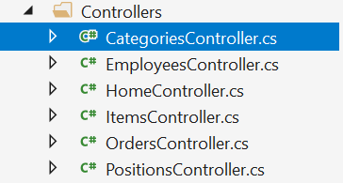

If you open the position controller you will see that this is the only one controller which has created mappings and some changes over the database. Your work is to look at this controller understand its methods and what is their purpose and then go to every other controller and create the mappings and do some changes to the database. **Don’t forget** when you modify the database to save the changes you have made! The final thing to do is to go to **MappingConfiguration** folder and open the **FastFoodProfile** class.



As you know a good way to organize your mapping configurations is with profiles. In this class you have to put the mapping configuration in the constructor.

When you are done with the controllers and the profile, start the application and test if it works correctly when you try to create a new employee position, new category and etc.